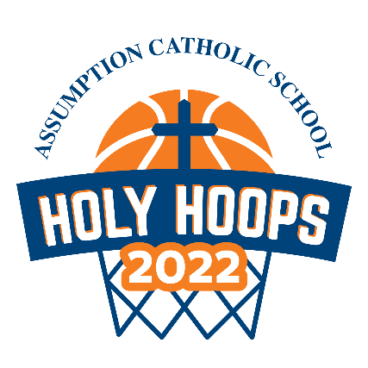
HOLY HOOPS SCHEDULE
The teams are set and ready to play! Holy Hoops starts on Tuesday, October 18TH!
The tournament will run daily in the Assumption Gym from October 18th – 21st,
3-6/6:30 pm.

Parents: We need your help! Please see the volunteer sign-up link to help make this event happen. This is a great opportunity to watch our students playing a sport they love and enjoying a little friendly competition.

https://www.signupgenius.com/go/20f054daeae2aa2fc1-7thannual

Tuesday, October 18th
3:15 Opening Ceremonies
3:30 Boys Pool Play Saint Sebastian vs Saint Padre Pio
4:00 Girls Pool Play Saint Lucy vs Saint Joan of Arc
4:30 Boys Pool Play Saint Michael vs Saint Lawrence
5:00 Girls Pool Play Saint Ann vs Saint Jude
5:30 Boys Pool Play Saint Dominic vs Saint Jerome

Wednesday, October 19th
3:15 Free Throw Competition
3:30 Boys Bracket Game 1 (Saint Jerome vs Saint Sebastian)
4:00 Girls Bracket Game 1 (St. Joan of Arc vs St. Ann)
4:30 Boys Bracket Game 2(Saint Dominic vs Saint Padre Pio)
5:00 Girls Bracket Game 2 (Saint Lucy vs Saint Jude)
5:30 Boys Bracket Game 3(Saint Lawrence vs Winner of Game 1)
6:00 Boys Bracket Game 4(Saint Michael vs Winner of Game 2)

Thursday, October 20th
3:15 Three-point Competition
3:30 Teacher vs Alumni Game
4:00 Boys Bracket Game 5
4:30 Girls Bracket Game 3
5:00 Boys Bracket Game 6
5:30 Girls Bracket Game 4
6:00 Boys Bracket Game 7

Friday, October 21st
3:15 Dribbling Competition
3:30 Boys Bracket Game 8
4:00 Girls Bracket Game 5
4:30 Boys Bracket Game 9
5:00 Girls Bracket Game 6 CHAMPIONSHIP
5:30 Boys Bracket Game 10 CHAMPIONSHIP
6:00(Elimination Game if Needed)/Awards
6:30 AWARDS
*Schedule is subject to change

