Human Food Chain Food Collection

- Canned fruit and vegetables
- Canned soup and chili
- Canned tuna and chicken
- Boxes of macaroni and cheese and cereal
- Tuna and chicken kits
- individual packets of crackers, fruit, applesauce
- Juice boxes or small bottles of water
- Canned spaghetti sauce and spaghetti noodles
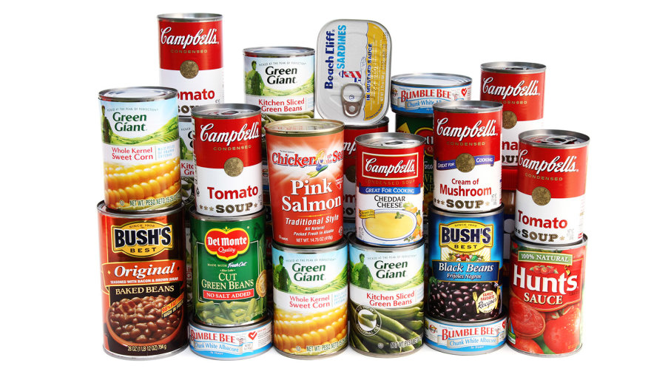
Drop off in front of sign, near office. If poster of cans is covered by food (by Nov. 22), free dress!

