**SPONSORSHIP FORM**

**DUE OCTOBER 10TH**

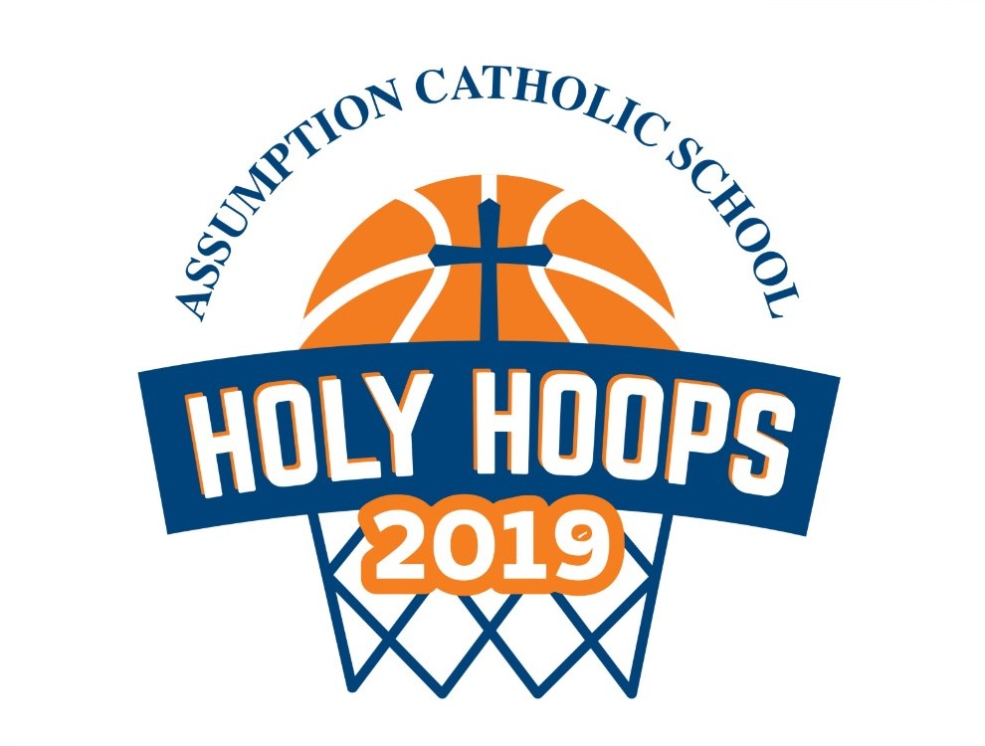

Dear Friends of Assumption Catholic School,

We hope you’ll join us in supporting our 5th Annual Holy Hoops Basketball Tournament. Holy Hoops is a 4-day, 4-on-4 basketball tournament for our 5th- 8th grade students that has become a favorite among students and community members alike. The running of this free community event relies upon support in the form of sponsorships from local families and businesses. Your generous donations go toward purchasing T-shirts for the teams, food and support for our coaches and referees, and prizes for winning teams. Our hope is that this event continues to be a long-standing tradition at our school, encouraging teamwork, good sportsmanship and community building.

The tournament is **October 22nd – 25th for 3:00 PM – 6:00 PM** and we welcome all spectators!

Please consider a donation in one of the following categories:

**Slam Dunk – $500**

* Includes large name on all team t-shirts and mention or ad in our event program

**Three-Point – $250**

* Includes mid-size name on all team t-shirts and listing in event program

**Teamwork – $100**

* Includes name on all team t-shirts and name in event program

**Starter – $50**

* Includes name in the event program.

Your generosity extends far beyond this single event and helps the students, alumni, and community connect around a sport we all love. Thank you for your consideration.

For more information please contact Stephanie Wolf at [stephwolf922@gmail.com](mailto:stephwolf922@gmail.com)

Send to:

Assumption Catholic School

2116 Cornwall Avenue

Bellingham, WA. 98225

Tel: 360-733-6133

*Donations are Tax Deductible*

Assumption Tax ID 91-0569883

**HOLY HOOPS SPONSORSHIP**

Name of Sponsor or Business Name

Contact Name and Number:

Method of payment:

* Enclosed is a check made payable to Assumption Catholic School in the amount of $____________
* Please charge my credit card in the amount of $_________Type of card (Visa, MC, AMEX)________

Card #____________________________Expiration Date_________________Security Code_________

Name as it appears on card_____________________________

If you would like your logo/ad to appear in the program ($250 or $500 levels)

please email high resolution (300 dpi or higher) print ready artwork to

Stephanie Wolf at stephwolf922@gmail.com by **October 10, 2019.**