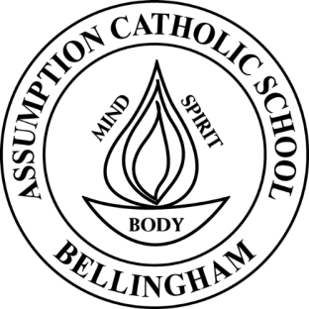
Mrs. Kushner Grade 2 2021-2022
This Photo by Unknown Author is licensed under CC BY
Important News: We will begin Measures of Academic Progress (MAPs) testing next week September 21st – 24th in Reading Language & Math.
Please make sure your child gets a good night’s sleep and eats a hearty and healthy breakfast during the weeks of testing. Thank you!

Dear Parents,
We began journal-writing prompts and “Daily Language Review” to build students
writing, editing, proofreading, grammar, & spelling skills. Our Daily 5 focuses on word work, writing, handwriting, reading to self, reading with a buddy, and listening to reading. Out new Benchmark Reading Program we are learning about being a good listener, how to take care of books, how to use our classroom library to choose a “just right” book, & writing responses to reading. Students have also practiced logging in to their IXL MATH & Reading A-Z accounts on their I pads.

This week our Science Genius lesson was about the four seasons time and day length. We watched a video and completed a DIY illustrating the four seasons.

Our Scholastic New Social Studies lesson was about Friendships making new friendships with our four new classmates. In Second Step we are learning how to be Respectful. We are thinking about how others want to be treated and when we treat them that way it helps us be respectful & being respectful helps us to be a better learner

We have not got our Go Math books in yet. However, we are doing Daily Math Practice & Daily Word Problems along with our Math Minutes.

We completed Spelling Unit 1 Short a words this week. Look for a printed copy to come home on Monday with Spelling List# 2 (10 words + seven challenge words). Look for a Tic-Tac-Toe to come home every Monday. Students have all week to complete this.

Please look for your child’s yellow folder on Wednesday for school announcements. 0n Friday your child will take home their red folder, completed work for the week, book orders, etc. for you to review with your child.

Our “Happy Camper” for the past two weeks is Caleb Abbey. He has a younger brother in kindergarten and an older sister in fourth grade. He loves cheese, his favorite book is Wings of Fire, he likes crocodiles, He loves Taekwondo, he can ski black diamonds, and his favorite color is blue!
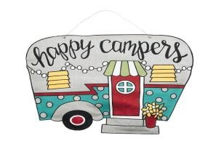
I am open to meeting after school at 3:30 p.m. any day, except for Wednesdays.
If you have concerns about your child’s progress socially, emotionally, or academically,
please feel free to contact free to contact me at 733-6133 ext. 4320 or email me at skushner@school.assumption.org.
Thank you for the opportunity to teach your children.
I feel blessed to be part of this amazing school community. Mrs. Kushner

